**Introduction to Call for Research and Community Service Fund Proposal**

By: **Chalid Luneto.**  October 19, 2020 11:33:18

An Introduction to Call for Research Fund Proposal and Community Service & Discussion on Mainstreaming Gender Equality and Social Inclusion in Research

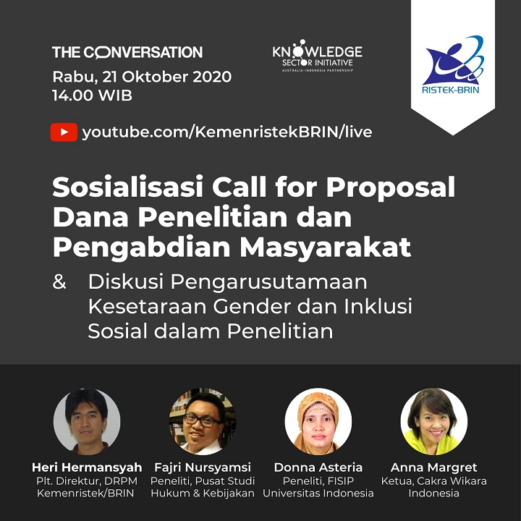

Source: Simlitabmas (October 19, 2020)

*Rabu, 21 Oktober 2020*: Wednesday, October 21, 2020

*14.00 WIB*: 14.00 Western Indonesia Time

*Sosialisasi Call for Proposal Dana Penelitian dan Pengabdian pada Masyarakat*: An Introduction to Call for Research Fund Proposal and Community Service

*Dan diskusi Pengarusutamaan Gender dan Inklusi Sosial dalam Penelitian*: and Discussion on Mainstreaming Gender Equality and Social Inclusion in Research

*Plt. Direktur DRPM Kemenristek/BRIN*: Acting Official of Director of DRPM Kemenristek/BRIN

*Peneliti*: Researcher

*Pusat Studi Hukum dan Kebijakan FISIP, Universitas Indonesia*: Center for Law and Policy Studies of FISIP, Universitas Indonesia

*Ketua Cakra Wikara Indonesia*: Director of Cakra Wikara Indonesia